The Cougar Pause
A Strategic Equity Resource for Planning, Decision Making,
and Conscious Reflection

What is The Cougar Pause?
The Cougar Pause is a Strategic Equity Resource designed to increase our chances of making decisions that lead to more equitable outcomes. It is meant to take out the guesswork of what equity work looks like in action. It consists of a set of critical questions that individuals or work teams can ask themselves while navigating decisions, both big and small. These questions prompt users to pause in their thinking and broaden their perspectives, leading to greater awareness about where we have choice and ability to confront disparate results.

Why use this Strategic Equity Resource?
Equity is a core value for us at Clackamas Community College—and we strive to uphold it in our daily actions.
By using the Cougar Pause, we live out our mission and core values by aligning our intentions with our actions. This resource helps people practice the principles of equity and DEI (Diversity, Equity, and Inclusion) consistently in our daily work. By offering a shared framework and language across the college, this resource aids in creating a consistent and ethical approach to decision-making, promoting fairness and preventing people from being left behind.
The Cougar Pause is a transformative resource that can help us break away from ingrained habits. These habits perpetuate inequities and hinder our progress and the well-being of our students and communities. With consistent use and practice, we can be the change we want to see.
The Cougar Pause also helps us document our thought processes, allowing for reflection and continuous learning. It prompts us to pause, ask ourselves critical questions, check our biases, and evaluate the quality of our decisions—encouraging intentional and mindful approaches for more equitable outcomes. This deliberate slowing down is crucial for achieving justice and equity. Additionally, the Cougar Pause serves as an educational resource, helping us grow, learn, and gain fresh perspectives beyond our usual habits.
WHAT IT IS | WHAT IT ISN’T
A resource to gather information from people impacted by the systems that govern our culture, norms and access to power and resources. | A solution to end racism or all discriminatory practices.
An invitation to pause and be more intentional rather than defaulting to ingrained habits and patterns of thinking. | A linear, simple, quick checklist to be 'checked off.'
A resource for mindset shifts, growth, and continuous improvement. | A tool for passing judgment.

When should we use the Cougar Pause?
This resource can be applied to any type of project or initiative across the college. It can scale to support large, strategic projects. These are initiatives with significant internal or external impact, often made by formal committees and councils – for example, budgeting, policy-making, governance, building college partnerships, and large-scale change initiatives.
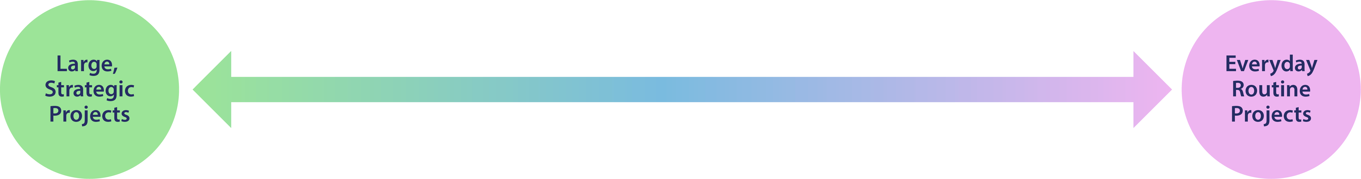
This resource can also support the everyday, routine projects and work – for example, designing meeting agendas or planning key events.
This resource provides opportunities to make choices. Here are some practical examples where the Cougar Pause can be used in a variety of situations:
 | People-related: Recruitment processes and professional development.
 | Academic and student service: Directly impacting the student experience, such as curriculum design and setting student expectations and accountability.
 | Operations: Examining, renewing, redesigning processes. Designing physical spaces, budgeting, and making administrative decisions.
 | Technology: Implementing new software, redesigning websites, technology that supports learning and work, tools such as social media or email.

Who should use the Cougar Pause?
This resource should be used by everyone within the Clackamas Community College ecosystem — all employees, Board of Education members, consultants to the college, and community members actively involved in college decisions. It can be utilized by individuals, small teams, and formal committees.
The cumulative effect of each of us using the Cougar Pause will lead to a significant overall impact.

Cougar Pause Worksheet

YOUR NAME/TEAM’S NAME:

DECISION BEING MADE:

Instructions on using this worksheet:
You can choose to complete this worksheet as a fillable document or print it out and write on it manually. Depending on your project, you may complete it individually or work through it with your team.

- Review all questions: At the start, read through all the prompting questions in this resource.
- Start with the Foundation: Review the ‘Foundation’ prompting questions, reflect on them, and answer as many as you can based on your current knowledge and experience. Once you’ve answered the questions, figure out what information is missing and what you may still need to know before moving on.
- Move through the stages: Continue reflecting and answering questions under each section: ‘Collaborate,’ ‘Implement,’ ‘Communicate,’ and ‘Evaluate, Learn, and Take Action.’
- Be flexible: Although we recommend starting with the 'Foundation,' the Cougar Pause is not a linear tool. Feel free to move back and forth between stages, revisiting and refining earlier decisions as needed. This iterative process can help enrich your outcomes and promote more equitable decision-making.
- Embrace the process: You may not have ready answers to all the questions, and some may require deeper exploration or discussion. This is normal! The purpose of the tool is to invite reflection and help you consider aspects you may not have thought about before.
- Identify actions: Based on your answers to the questions and what you need to know, identify what actions you will take. There is space at the end of the document to take notes.

Here are some important things to keep in mind as you work through the tool:
- Equity work takes time. As you work through the Cougar Pause worksheet, allow yourself the space and time needed—it may take days or even weeks. This isn't a checklist to complete, but rather an opportunity to pause, reflect, and broaden your thinking and actions to create more equitable outcomes.
- Avoid feeling pressured to use "equity language." Be genuine and express yourself in the words that you have.
- It’s okay if you don’t have answers to every question or feel unsure about what’s “right.” The Cougar Pause is not about judgment or penalization; it’s a tool to foster learning, growth, and meaningful reflection.
Cougar Pause
Visual Overview:
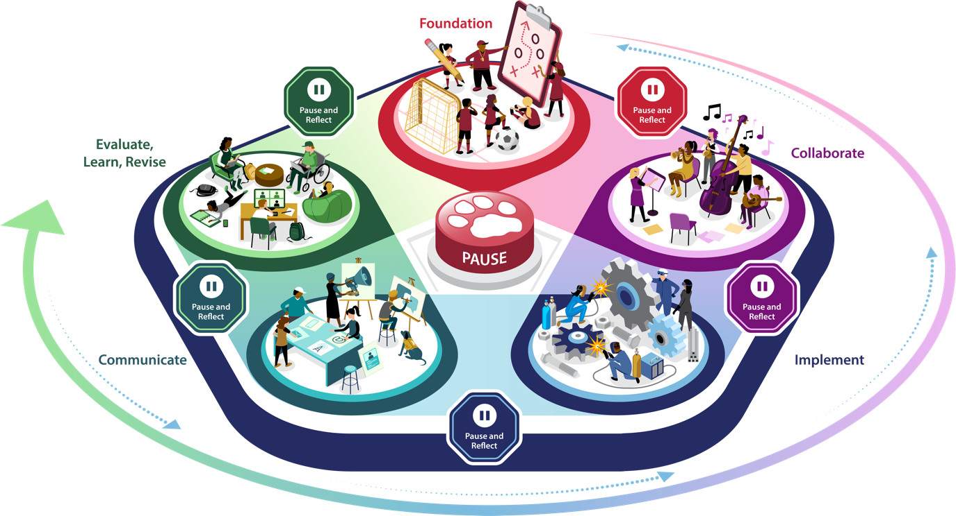
GET STARTED!
- Read through all the questions.
- Go back through and answer the questions that you can.
- Once you’ve answered the questions, figure out what information is missing and what you still may need to know before moving on.
- Based on the answers to your questions and what you need to know, what actions are you going to take?

NEED HELP? If you have questions about using this tool, please email diversity@clackamas.edu.
Foundation Next Stage | Actions
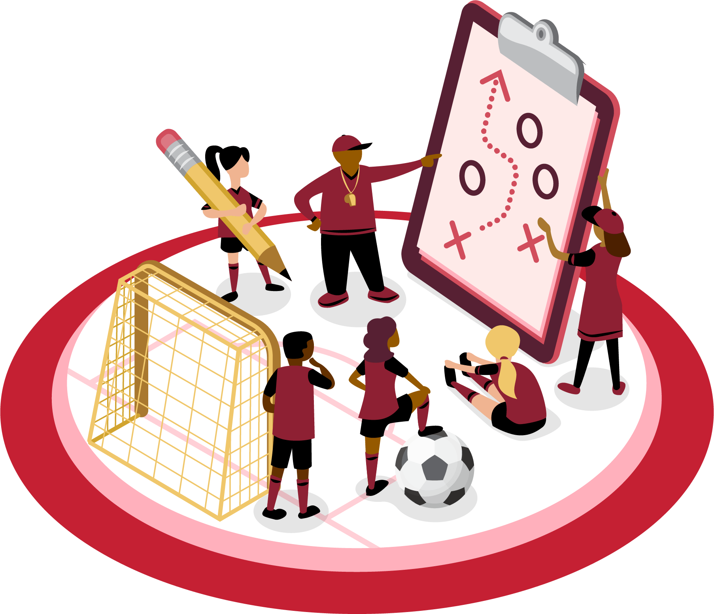
Questions for Reflection:
- What is the primary goal of this work? What is the deeper purpose behind it?

- What specific outcomes are you aiming to accomplish? Why are these outcomes important?

- Who are you centering in this work? Be specific about their identities and narrow your focus. Examples might be bilingual high school students at Milwaukie High School, or Black male students currently attending CCC full-time. (For more ideas to help you specifically define your audience, please refer to the Identity Groups resource document.)

- How will this work support or challenge those whom we are centering?

- What parameters inform or constrain your work? What are the potential tradeoffs and benefits?

- What knowledge, insights, biases, or assumptions are you bringing into this work —from background research, existing feedback, Clackamas Community College cultural norms, etc.?

- Are you the most informed person to answer these questions? If not, who else might you bring in to help?

Collaborate Next Stage | Previous Stage | Actions

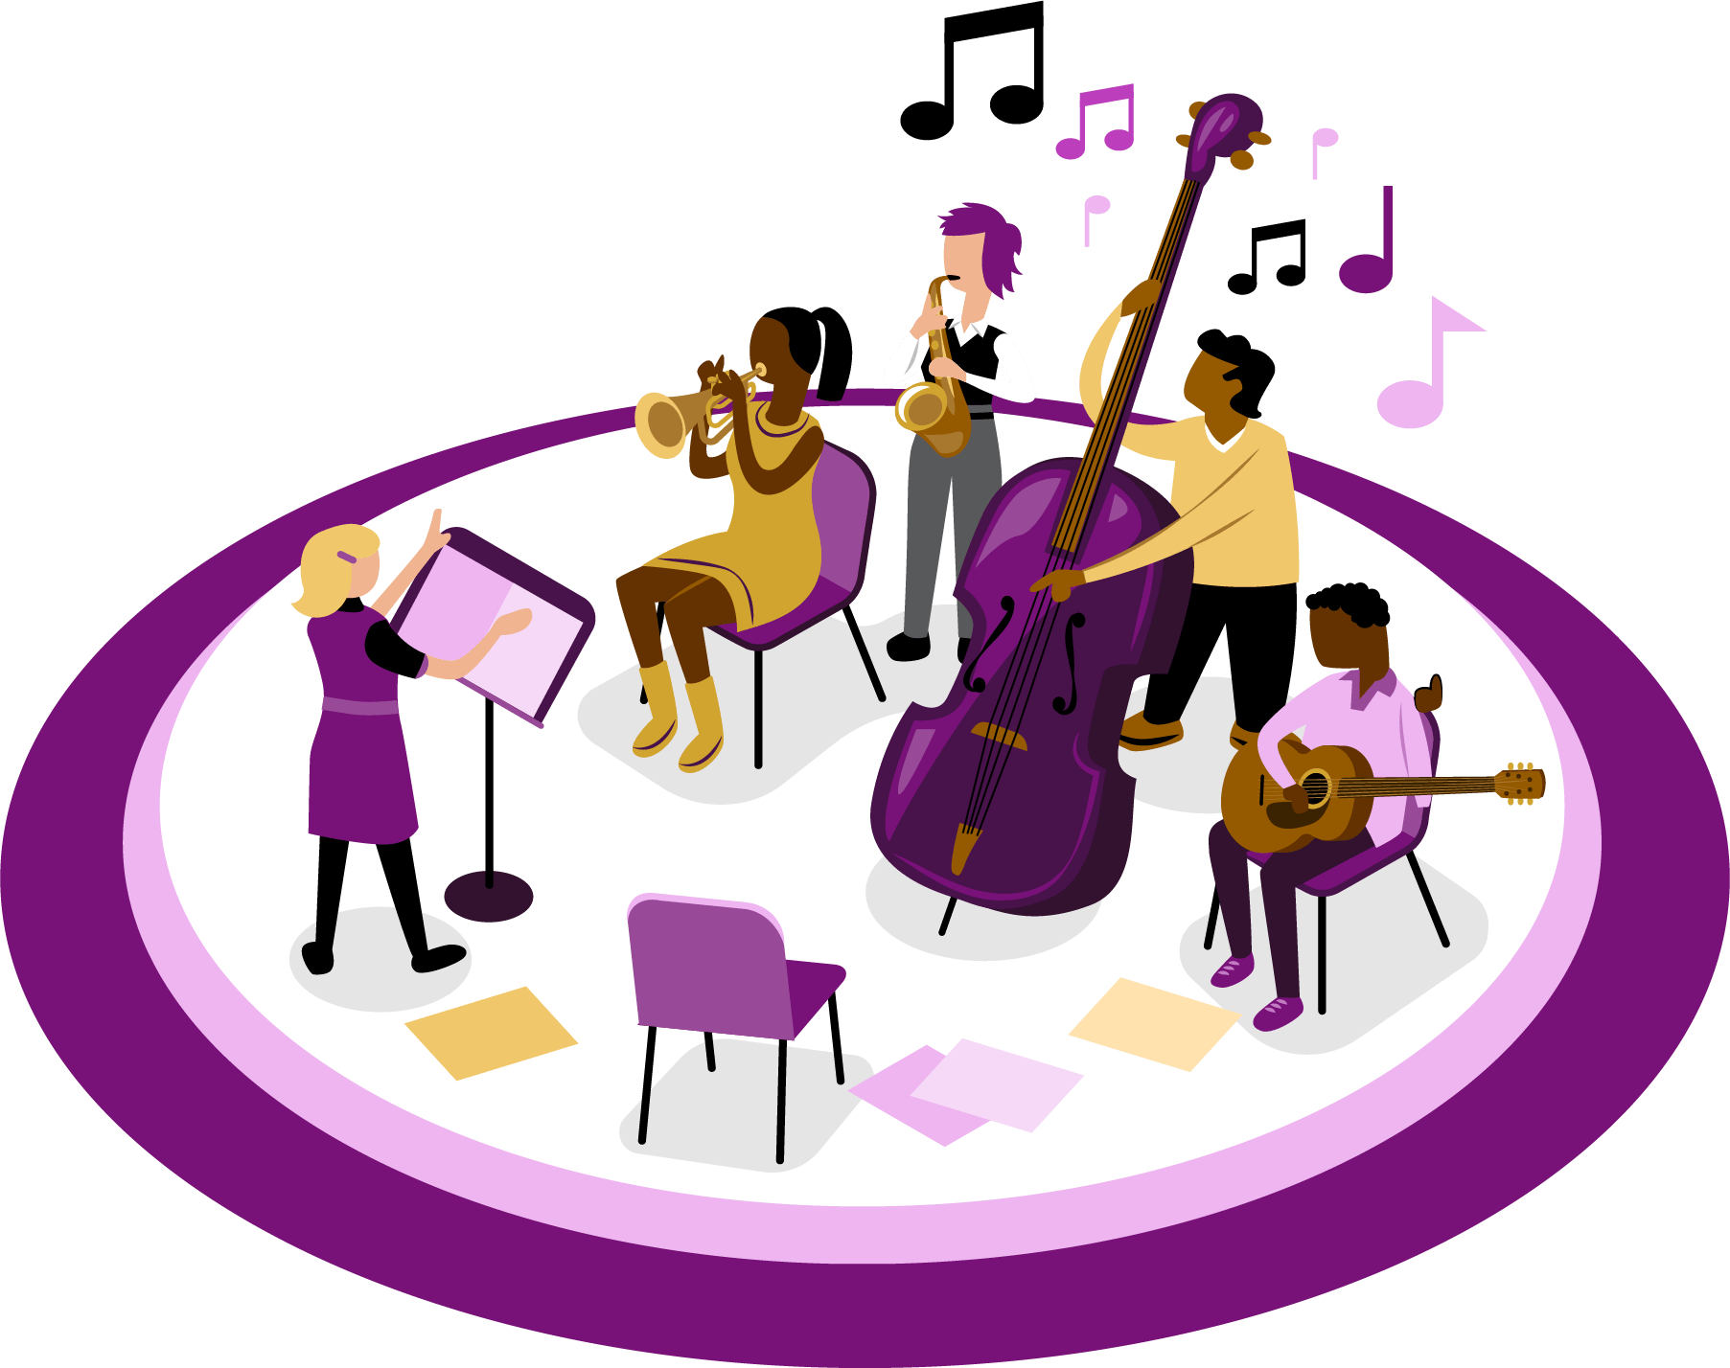

Questions for Reflection:
- Who do you need to engage with and hear from about this work? Prioritize the centered audiences identified during the Foundation phase.

- What techniques will be most effective and relevant when listening to and collaborating with your centered audiences (such as online surveys, focus groups, types of questions asked, anonymous feedback, etc.)?

- How will you best support diverse opinions so they can be shared during this collaboration, in a courageous space, while mitigating power dynamics?

Implement Next Stage | Previous Stage | Actions

Questions for Reflection:
- How did you incorporate what you learned during your collaborations into this implementation plan?

- How is your plan specific and responsive to the needs of those we are centering, and how does it best support their full participation?

- Do you have sufficient time and resources allotted to the work to avoid overwhelming the people involved? If not, can you get more time or the resources you need?

- What indicators will you use to evaluate the results and outcomes of the work?

- How are you adapting your work as it's implemented to respond to newly emerging needs, situations, and feedback from centered audiences?

Communicate Next Stage | Previous Stage | Actions
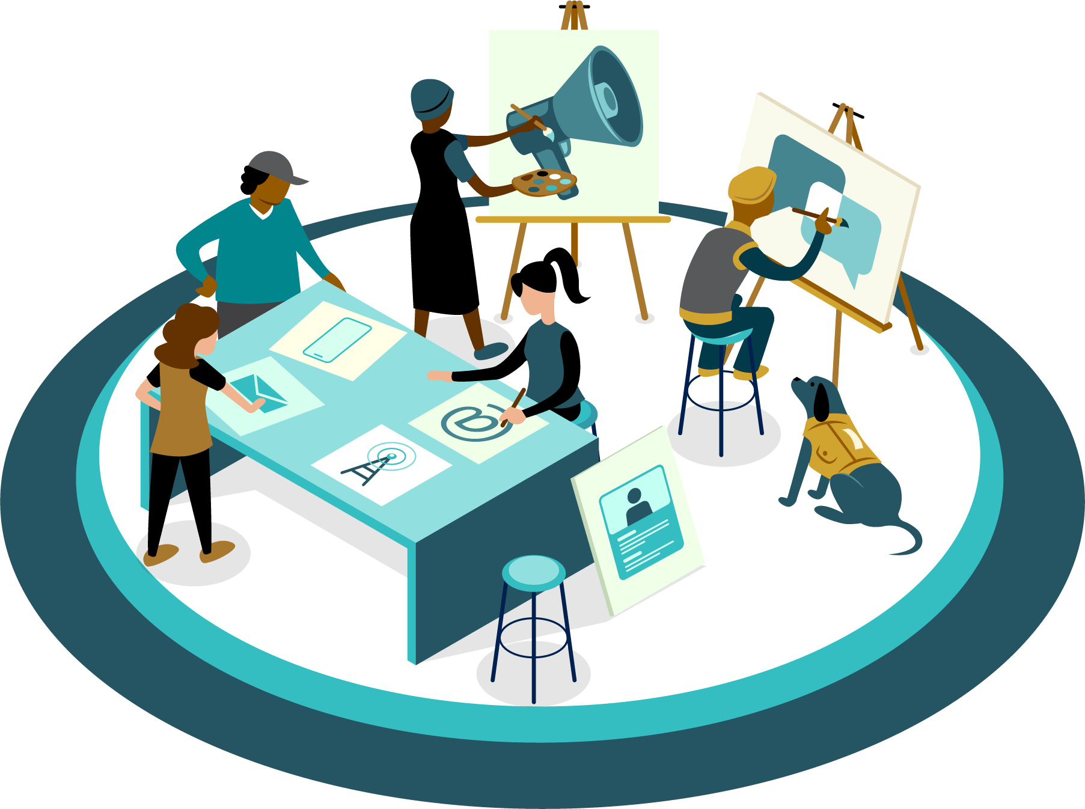

Questions for Reflection:
- How is your communication plan culturally responsive and tailored to
specific audiences?

- What information can you share to help audiences understand how this work will impact/benefit them? What else do they need to know?

- What are the best ways/formats to communicate with all of your audiences, especially those centered in this work?

- When will you begin communicating? Who is best suited to deliver communication to your centered audiences?

Evaluate, Learn, Revise Previous Stage | Actions
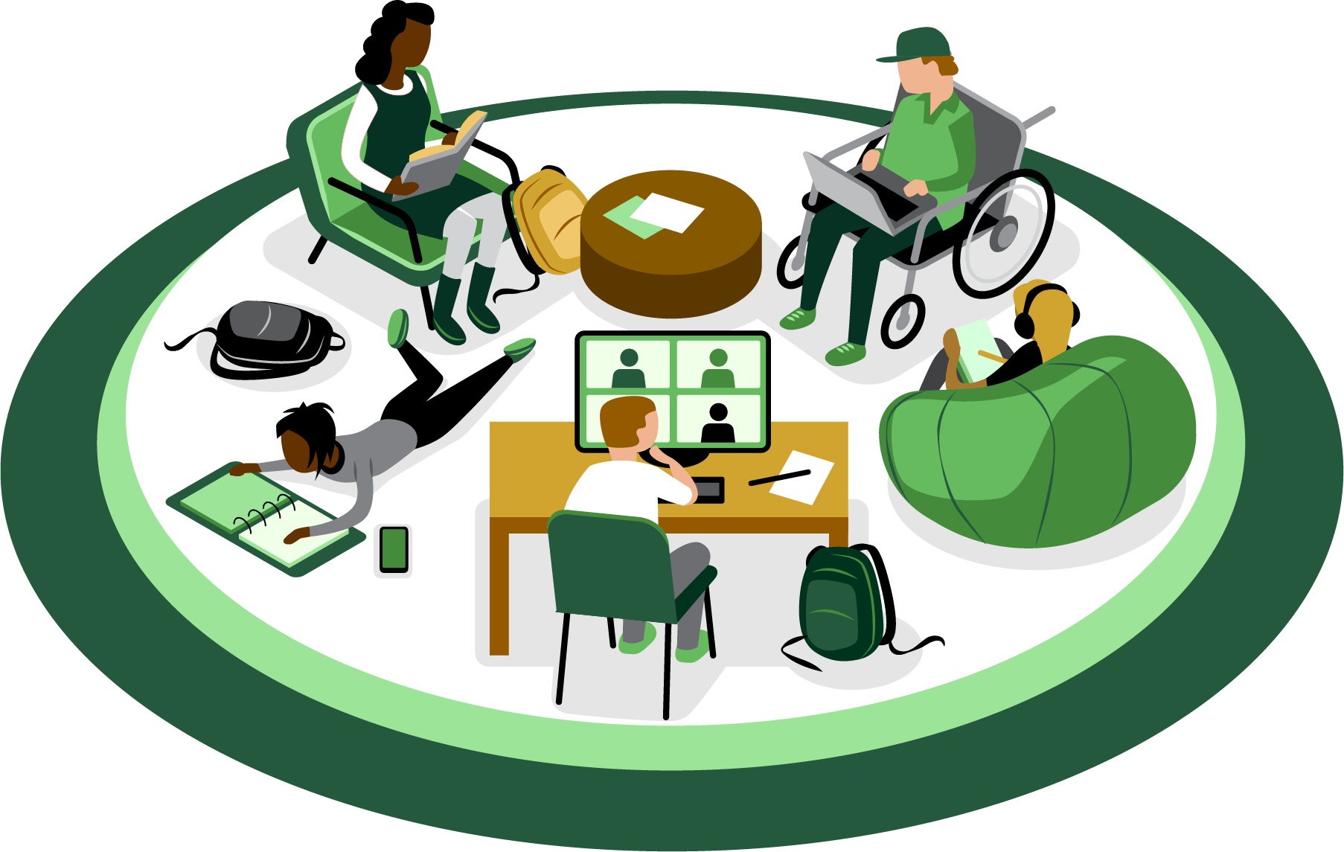
Questions for Reflection:
- How do you feel you have progressed toward achieving your initial goal?

- What outcomes, successes, and/or unintended consequences are you observing across different groups or segments? How might your reflections and observations influence what you do in the future?

- What are your key lessons learned? How might you share these lessons with others?

- What accommodations and revisions would you make to the work in the future?

- How did this tool support your work? How can you use it differently in the future to be more effective?

Actions

Final Actions You Will Take:

